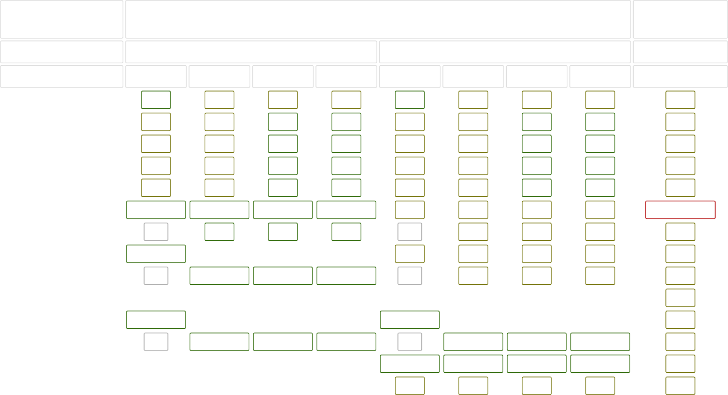Common Data Structure Operations
Data Structure
Time Complexity

Average
Worst
Space Complexity
Worst

 | Access | Search | Insertion | Deletion | Access | Search | Insertion | Deletion
Array | Θ(1) | Θ(n) | Θ(n) | Θ(n) | O(1) | O(n) | O(n) | O(n) | O(n)
Stack | Θ(n) | Θ(n) | Θ(1) | Θ(1) | O(n) | O(n) | O(1) | O(1) | O(n)
Queue | Θ(n) | Θ(n) | Θ(1) | Θ(1) | O(n) | O(n) | O(1) | O(1) | O(n)
Singly-Linked List | Θ(n) | Θ(n) | Θ(1) | Θ(1) | O(n) | O(n) | O(1) | O(1) | O(n)
Doubly-Linked List | Θ(n) | Θ(n) | Θ(1) | Θ(1) | O(n) | O(n) | O(1) | O(1) | O(n)
Skip List | Θ(log(n)) | Θ(log(n)) | Θ(log(n)) | Θ(log(n)) | O(n) | O(n) | O(n) | O(n) | O(n log(n))
Hash Table | N/A | Θ(1) | Θ(1) | Θ(1) | N/A | O(n) | O(n) | O(n) | O(n)
Binary Search Tree | Θ(log(n)) | Θ(log(n)) | Θ(log(n)) | Θ(log(n)) | O(n) | O(n) | O(n) | O(n) | O(n)
Cartesian Tree | N/A | Θ(log(n)) | Θ(log(n)) | Θ(log(n)) | N/A | O(n) | O(n) | O(n) | O(n)
B-Tree | Θ(log(n)) | Θ(log(n)) | Θ(log(n)) | Θ(log(n)) | O(log(n)) | O(log(n)) | O(log(n)) | O(log(n)) | O(n)
Red-Black Tree | Θ(log(n)) | Θ(log(n)) | Θ(log(n)) | Θ(log(n)) | O(log(n)) | O(log(n)) | O(log(n)) | O(log(n)) | O(n)
Splay Tree | N/A | Θ(log(n)) | Θ(log(n)) | Θ(log(n)) | N/A | O(log(n)) | O(log(n)) | O(log(n)) | O(n)
AVL Tree | Θ(log(n)) | Θ(log(n)) | Θ(log(n)) | Θ(log(n)) | O(log(n)) | O(log(n)) | O(log(n)) | O(log(n)) | O(n)
KD Tree | Θ(log(n)) | Θ(log(n)) | Θ(log(n)) | Θ(log(n)) | O(n) | O(n) | O(n) | O(n) | O(n)

Array Sorting Algorithms
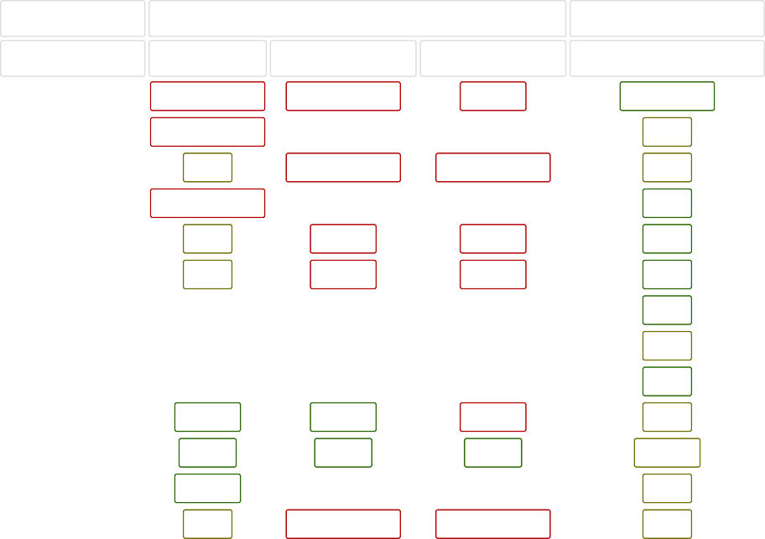
Algorithm
Time Complexity
Quicksort Mergesort Timsort Heapsort Bubble Sort Insertion Sort Selection Sort Tree Sort Shell Sort Bucket Sort Radix Sort Counting Sort
Cubesort
Best
Ω(n log(n))
Average Worst
Θ(n log(n)) O(n^2)
Space Complexity Worst
O(log(n))
Ω(n log(n))
Θ(n log(n))
O(n log(n))
O(n)
Ω(n)
Θ(n log(n))
O(n log(n))
O(n)
Ω(n log(n))
Θ(n log(n))
O(n log(n))
O(1)
Ω(n)
Θ(n^2)
O(n^2)
O(1)
Ω(n)
Θ(n^2)
O(n^2)
O(1)
Ω(n^2)
Θ(n^2)
O(n^2)
O(1)
Ω(n log(n))
Θ(n log(n))
O(n^2)
O(n)
Ω(n log(n))
Θ(n(log(n))^2)
O(n(log(n))^2)
O(1)
Ω(n+k)
Θ(n+k)
O(n^2)
O(n)
Ω(nk)
Θ(nk)
O(nk)
O(n+k)
Ω(n+k)
Θ(n+k)
O(n+k)
O(k)
Ω(n)
Θ(n log(n))
O(n log(n))
O(n)

